**INSTITUTE OF ENGINEERING**

ADVANCED COLLEGE OF ENGINEERING AND MANAGEMENT

Kupondole, Lalitpur

**(AFFILIATED TO TRIBHUVAN UNIVERSITY)**



Lab no:3

Subject: DSAP

**Submitted By: Submitted To:**

Department of Computer

and

Electronics Engineering

Name: Sameep Dhakal

Roll no: ACE074BCT063

Date: 09/07/2021

# **Lab-3 Elementary signals**

## **Objective:**

* To learn about elementary signals and plot them.

## **Theory**

Noise Wave:

A noise wave is the pattern of disturbance caused by the movement of energy traveling through a medium (such as air, water, or any other liquid or solid matter) as it propagates away from the source of the sound.

There are 5 different types of elementary signals: unit step signal, rectangular signal, ramp signal, triangular signal, and impulse signal.

Unit step signal:

Unit step signal is like flipping switch on or off. If t>0 then switch will on, if t<0 will be off. Ku(t), K is constant and is use in ramp signal.

Rectangualar signal:

Rectangular signal is a little more complex than unit step signal. We could say it is combine of two unit step signal. But more importantly there is a theta that we add in to the signal as new unknown.

Unit impulse signal:

An impulse signal is a special signal is to model certain events. Impulse signal is not realizable, the out put of the impulse signal is usually infinity at certain values.

Unit Ramp Signal:

The ramp signal is a unary real signal, whose graph is shaped like a ramp. It can be expressed by numerous definitions, for example "0 for negative inputs, output equals input for non-negative inputs".

## **Code:**

1. PLOT Cos WAVE, NOISE WAVE AND NOISE ADDED SINE WAVE ALL IN SINGLE SCREEN

clc;

clear all;

Amp = 5;

f = 5;

w = 2*pi*f;

t = 0 : 0.001: 1;

y = Amp * cos(w*t);

subplot(3, 1, 1);

plot(t,y);

grid on;

xlabel('angle');

ylabel('amplitude');

title('cosine wave plot/ Sameep Dhakal/563');

z = rand(1,length(t));

subplot(3,1,2);

plot(t,z);

grid on;

xlabel('angle');

ylabel('amplitude');

title('noise wave plot/ Sameep Dhakal/563');

a = y + z;

subplot(3,1,3);

plot(t,a);

grid on;

xlabel('angle');

ylabel('amplitude');

title('noise added cosine wave plot/ Sameep Dhakal/563');

grid on;

Output:

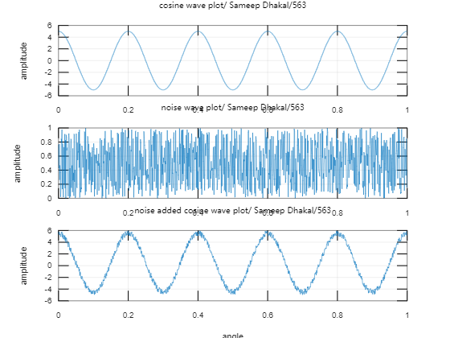

1. Construct both continuous and discrete-time unit impulse signal.

clc;

clear all;

i = 1;

for t = -2:0.001:2

if(t==0)

x(i) = 1;

else

x(i) = 0;

end;

i = i +1;

end;

t = -2:0.001:2;

subplot(2,1,1);

plot(t,x);

grid on;

xlabel('time');

ylabel('amplitude');

title('unit impulse signal plot/Sameep Dhakal/563');

clear all;

i = 1;

for t = -2:0.1:2

if(t==0)

x(i) = 1;

else

x(i) = 0;

end;

i = i +1;

end;

t = -2:0.1:2;

subplot(2,1,2);

stem(t,x);

grid on;

xlabel('time');

ylabel('amplitude');

title('unit impulse signal’);

output:

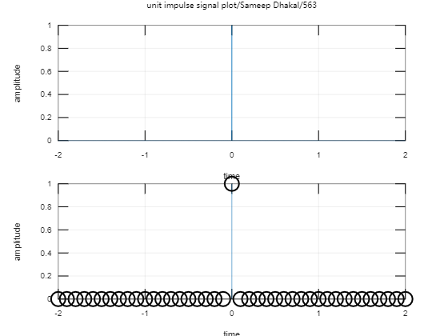

1. Construct both continuous and discrete-time unit step signal.

clc;

clear all;

i = 1;

for t = -2:0.001:2

if(t>=0)

x(i) = 1;

else

x(i) = 0;

end;

i = i +1;

end;

t = -2:0.001:2;

subplot(2,1,1);

plot(t,x);

grid on;

xlabel('time');

ylabel('amplitude');

title('continuous unit step signal plot/Sameep Dhakal/563');

clear all;

i = 1;

for t = -2:0.1:2

if(t>=0)

x(i) = 1;

else

x(i) = 0;

end;

i = i +1;

end;

t = -2:0.1:2;

subplot(2,1,2);

stem(t,x);

grid on;

xlabel('time');

ylabel('amplitude');

title('discrete unit step signal plot/Sameep Dhakal/563');

output:

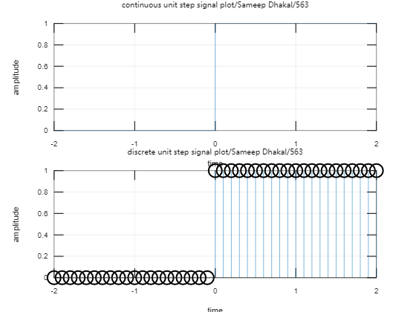

1. Construct both continuous and discrete-time unit ramp signal.

clc;

clc;

clear all;

i = 1;

for t = -2:0.001:2

if(t>=0)

x(i) = t;

else

x(i) = 0;

end;

i = i +1;

end;

t = -2:0.001:2;

subplot(2,1,1);

plot(t,x);

grid on;

xlabel('time');

ylabel('amplitude');

title('continuous ramp signal plot/Sameep Dhakal/563');

i = 1;

for t = -2:0.001:2

if(t>=0)

x(i) = t;

else

x(i) = 0;

end;

i = i +1;

end;

t = -2:0.001:2;

subplot(2,1,2);

stem(t,x);

grid on;

xlabel('time');

ylabel('amplitude');

title('discrete ramp signal plot/Sameep Dhakal/563');

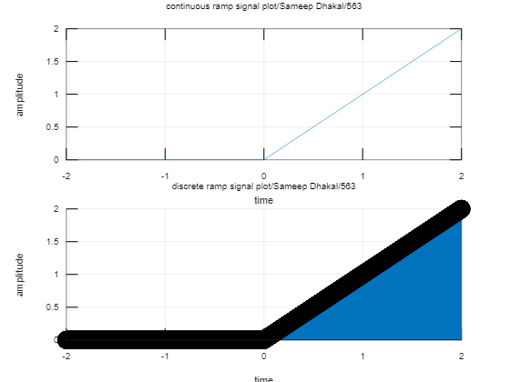

1. Construct a rectangular pulse signal defined by the signal.

Rect(t)=1, for |t|<1/2

=1/2, for |t|=1/2

=0 otherwise

clc;

clear all;

i = 1;

for t = -2:0.001:2

if(abs(t)>1)

x(i) = 0;

else

x(i) = 1;

end;

i = i +1;

end;

t = -2:0.001:2;

subplot(2,1,1);

plot(t,x);

xlabel('time');

ylabel('amplitude');

title('continuous square signal plot/Sameep Dhakal/563');

grid on;

clear all;

i = 1;

for t = -2:0.001:2

if(abs(t)>1)

x(i) = 0;

else

x(i) = 1;

end;

i = i +1;

end;

t = -2:0.001:2;

subplot(2,1,2);

stem(t,x);

xlabel('time');

ylabel('amplitude');

title('Discrete square signal plot/Sameep Dhakal/563');

output:

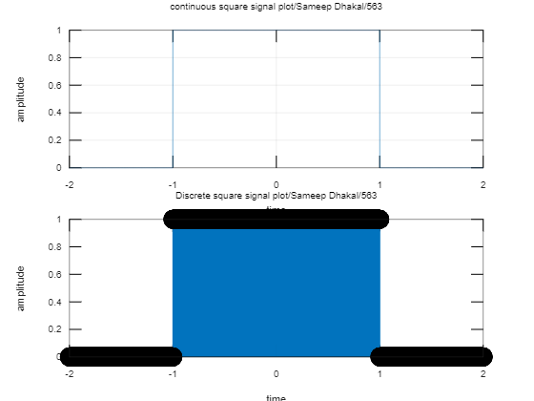

## Discussion and conclusion

In this lab we plotted the elementary signals and analyzed their result.